DEVELOPERSHUB CORPORATION RED
TEAMING

TARGET: OWASP JUICE SHOP

Week 1 : Task

Week 01: Identification & Exploit
Objective : To identify and exploit critical vulnerabilities (SQL Injection and Cross-Site Scripting) within the web application to determine the potential security risk.

Submitted By :
Usman Ghani

DHC ID:
2502

Instructor :
Faizan Khan

Week :
Red Team - Week 1

​Date :
April 7, 2026

- TARGET IDENTIFICATION (NETWORK RECONNAISSANCE)

Description: The assessment began with identifying the target application's IP address on the local network. Using the Netdiscover tool on Kali Linux, a scan was performed on the host-only adapter range. The scan successfully identified the OWASP Juice Shop server at IP address 192.168.56.108.

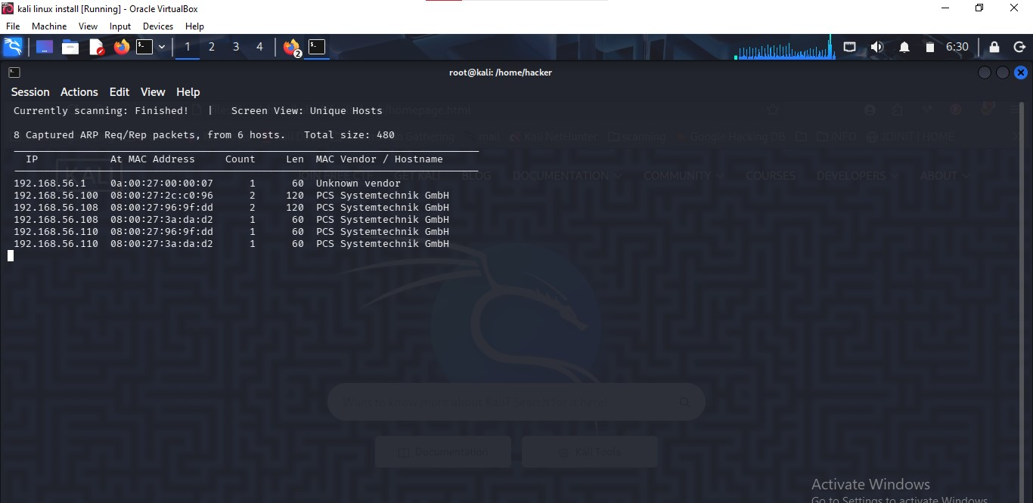

- WEB APPLICATION CONNECTIVITY VERIFICATION

Description: After identifying the target IP (192.168.56.108), I accessed the web application through the browser on port 3000. This confirmed that the application is live and accessible for security assessment.

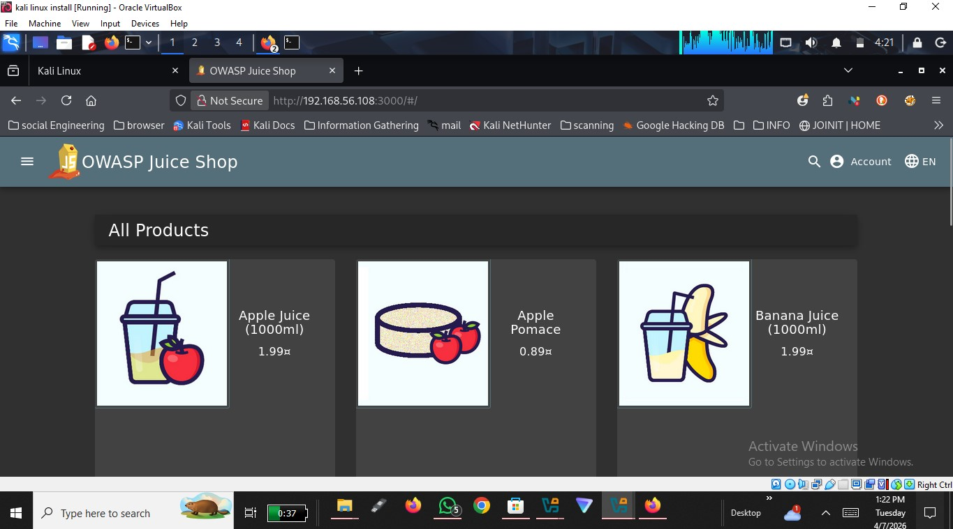

- VULNERABILITY EXPLOITATION: SQL INJECTION (SQLI)

Description: I identified a critical SQL Injection vulnerability on the login page. By using the ' OR 1=1 - - in the email field, I was able to bypass the authentication mechanism and gain full administrative access to the system.

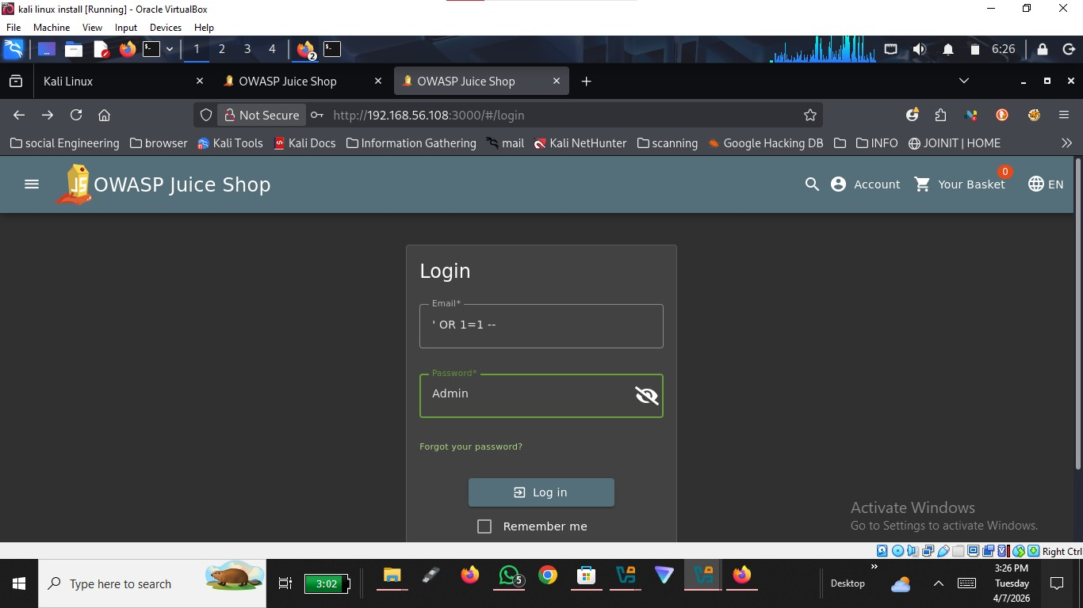

- VULNERABILITY EXPLOITATION: REFLECTED XSS

Description: I performed an XSS attack by injecting a JavaScript payload <iframe src="javascript:alert('Hacked_by_Usman')"> into the application's search bar. The application failed to sanitize the input, resulting in a successful script execution and a browser alert popup.

